Conceptual Design and Automation of an EOT Crane-Based Positioning Platform for Large-Aperture Antenna Characterization
Alok Dadhich⁽¹⁾, Rakesh Kumar⁽²⁾, Jaswant⁽²⁾, Jigar M. Pandya⁽²⁾
⁽¹⁾Vishwakarma Institute of Technology, Pune; alokdadhich479@gmail.com
⁽²⁾Space Applications Centre (ISRO); rakeshkr@sac.isro.gov.in

Abstract: This paper presents the conceptual design and software architecture of a low-cost positioning platform based on an existing Electric Overhead Travelling (EOT) crane for future large-aperture antenna characterization. Rather than replacing the existing crane with a dedicated scanner, the proposed approach retrofits the crane using incremental encoders, an embedded control node, RS-485/MEMOBUS communication, and a browser-based supervisory interface while preserving the original safety and drive systems. The work focuses on system architecture, positioning uncertainty analysis, motion-control strategy, scan-planning software, and communication design. A software prototype demonstrating coordinate management, raster scan planning, machine-limit enforcement, and operator interaction has been developed and evaluated using simulated data. The manuscript discusses expected mechanical uncertainty sources including brake delay, drive train compliance, backlash, and wheel-rail interaction, and proposes a practical control strategy intended to minimize corrective reversals. The present work is limited to conceptual design and software validation. Hardware implementation, positioning characterization and antenna measurements are planned for future work.

Keywords— Electric Overhead Travelling (EOT) crane, antenna positioning system, large-aperture antenna measurement, near field antenna measurement, motion control, encoder-based positioning, scan planning, industrial automation, positioning uncertainty.
- INTRODUCTION
Accurate positioning systems are essential for the characterization of gravity sensitive, large antennas, where the measurement probe must traverse a large scan aperture with adequate positioning accuracy and repeatability [1]. Conventional antenna measurement systems employ dedicated multi-axis positioning mechanisms that provide high precision [1]-[3], [5]-[6] but require specialized mechanical infrastructure, resulting in significant procurement and installation costs.
Electric Overhead Travelling (EOT) cranes are widely available in industrial and research facilities and offer large travel ranges and robust mechanical structures. Although primarily intended for material handling, their existing infrastructure provides an opportunity to develop a cost-effective positioning platform through appropriate sensing, communication, and supervisory control. However, mechanical factors such as brake delay, drivetrain compliance, gearbox backlash, and wheel–rail interaction must be considered before such systems can be adapted for precision positioning.
This paper presents the conceptual design and automation architecture of an EOT crane-based positioning platform intended for future large-aperture antenna characterization. The proposed approach preserves the existing crane drive system and safety hardware, while incorporating encoder-based position sensing; RS-485/MEMOBUS communication, wireless monitoring, and a browser-based supervisory interface. A software prototype has been developed to demonstrate coordinate management, scan planning, machine-limit enforcement, and operator interaction using simulated data.
The principal contributions of this work are the conceptual system architecture, software prototype, communication framework, positioning uncertainty analysis, and a practical motion-control strategy for hardware implementation. Experimental validation and antenna measurements are beyond the scope of the present work and are planned as future developments.
The remainder of this paper is organized as follows. Section II presents the application requirements, followed by the proposed system architecture, hardware design, communication framework, software prototype, positioning uncertainty analysis, control strategy, planned validation methodology, discussion & limitations and concluding remarks.
- MOTIVATION AND APPLICATION REQUIREMENT
Near-field characterization of gravity-sensitive antennas (over 6 m in diameter) needs a motion system that can cover a large scan area [2]. Dedicated scanners can do this, but they're expensive and take a lot of time to install. EOT cranes are a good fit instead — they're already built for large travel ranges and have a strong structure, and since the crane already exists, retrofitting it skips the cost and reduces time of buying and installing a new dedicated scanner. [4].

- SYSTEM ARCHITECTURE
As shown in Fig. 1, the proposed system is organized into three functional groups: Sensing and Power, the Control Path, and the Monitoring Path.
The Sensing and Power group supplies the electronics with a regulated power source and measures the crane's position along the rail. This group feeds directly into the Control Path.
The Control Path is the core of the system: it decides what motion to command and drives the crane accordingly. It runs entirely over a wired connection — the control node reads position from the encoder, issues commands over RS-485 to the motor drive, and the motor drive moves the crane. This chain does not depend on any wireless link to function, which is a deliberate design choice: even if the wireless connection is lost or degraded, the Control Path continues operating on its most recently received command.
The Monitoring Path is separate from the Control Path and connects to it only through a wireless LoRa link. Its role is to let an operator see the crane's status and send new commands; it carries no motion-critical function. A ground-side radio node receives telemetry from the crane and relays it to a PC over USB, where it is logged and made available to the operator interface described in Section VI.
This grouping reflects the underlying design principle of the system: the part of the system responsible for actually moving the crane is wired and self-contained, while the part responsible for human monitoring and command input is wireless and sits outside the motion-critical loop. This separation is intended to ensure that a wireless disruption or an unresponsive interface cannot directly affect crane motion; this property is presented as a design rationale and has not yet been experimentally verified, as noted in Section IX.
Separating the system this way keeps the two design concerns distinct: getting the crane to move correctly is treated purely as a wired, real-time engineering problem, while giving the operator visibility and control is treated as a separate, communication problem layered on top. This distinction is carried through the rest of the paper — Section IV describes the hardware that makes up each group, Section V describes how they communicate, and Section VI describes the interface built on top of the Monitoring Path. The uncertainty sources and control strategy discussed in Sections VII and VIII apply specifically to the Control Path, since that is the chain directly responsible for the crane's physical motion.

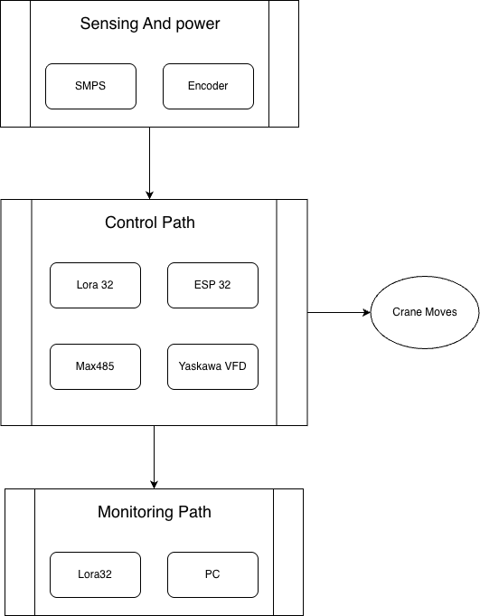
Fig. 1. System block diagram

- Hardware Design
The hardware required for this retrofit falls into four categories, each addressing a specific need created by adapting an existing crane rather than building a dedicated scanner from scratch: a way to sense the trolley's position, since the crane has no native position feedback; a control node to read that position and command the drive; power and protection suited to an environment with industrial switching loads nearby; and an enclosure to keep the electronics safe without blocking the wireless link. Each of these is discussed in turn below.
- Position Sensing
The encoder needs to measure how far the trolley moves along the rail, but the existing motor has no built-in way to mount a shaft encoder — so instead of mounting the encoder on the motor itself, the design uses a small measuring wheel that rides directly on the rail and turns as the trolley moves. This wheel drives an incremental encoder: a 2000 PPR quadrature encoder, 5 V, IP65-rated, chosen for its industrial-grade sealing since it sits exposed. near the rail. The measuring wheel is 50 mm in diameter, giving a circumference of 157.08 mm. Using 4× quadrature decoding, this gives a theoretical resolution of
 | $∆x= \frac{157.08}{2000×4}=0.0196 mm/count$ | (1)
This number comes purely from the datasheet and the wheel geometry — it's the theoretical resolution of the sensor itself, not a promise of how accurate the whole system will actually be once gearbox play, brake behavior, and wheel slip are factored in. The encoder cable is planned to be shielded with a single-point ground, and it's meant to run alongside the existing power cable in the crane's cable chain rather than needing a separate cable run.
- Control Node and RS-485 Interface
The system needs something to sit between the encoder and the motor drive — reading position, deciding what to command, and talking to the drive over its existing communication port — without touching the drive's original wiring. This role is filled by an embedded control node built around a microcontroller board with a built-in LoRa radio, display, and USB interface, which keeps the design to one board instead of separate radio and controller modules. Since the motor drive expects RS-485 (its Modbus/MEMOBUS port), a small RS-485 transceiver chip is added to translate between the microcontroller's signals and the drive's interface, connected using shielded twisted-pair cable inside the control panel. Inside the controller, real-time control and wireless communication are kept as separate tasks, so that wireless activity can't interfere with the timing of the control loop — this is still a design decision on paper and hasn't been tested on real hardware yet.
- Power and Protection
The electronics need their own clean power supply, since industrial switching loads like brake coils and contactors can introduce voltage spikes that ordinary electronics aren't built to handle. A small 5 V, 2 A power module is used to supply the control node and sensors. To protect against the expected switching transients from brake-coil operation, transient-voltage-suppression diodes are planned on the encoder and communication lines, along with local decoupling to smooth out voltage sag during contactor switching, and an inline fuse to protect the supply itself. These are standard precautions for electronics operating near industrial switching loads, though their actual effectiveness in this specific installation hasn't been evaluated yet.
- Enclosure
The electronics need physical protection from the industrial environment they'll sit in, while still keeping the wireless link usable. For this reason, they're housed in a sealed, IP65-rated plastic enclosure — plastic rather than metal, specifically so it doesn't block or weaken the 868 MHz wireless signal — with cable glands for wiring entry and an externally mounted antenna.
- Communication Architecture

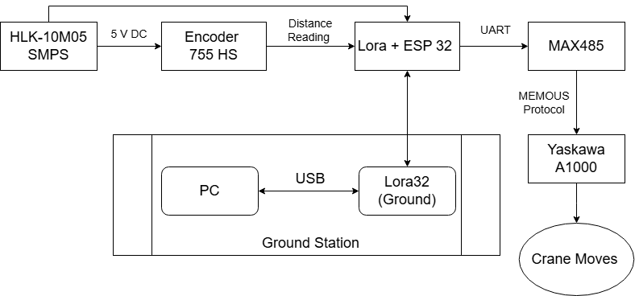
Fig. 4. Communication Architecture

Encoder link: The encoder (755HS, 2000 PPR) is read by the Lora+ESP32 control node via interrupt-driven pulse decoding, with position computed as x = N × 0.0196 mm (Eq. 1). On power-up, each axis is proposed to move in reverse at reduced speed toward a hard-stop limit switch, at which point the position count would be reset to zero. This hardware-referenced origin is intended to serve as the machine-absolute coordinate reference used throughout the system.
Controller–drive link: The Lora+ESP32 node communicates with the MAX485 transceiver over UART, which converts this to RS-485 for the drive. Communication with the motor drive (YASKAWA S1000) is proposed over MEMOBUS [7], YASKAWA's implementation of Modbus RTU over RS-485 [8]. The controller is proposed to issue commands instructing the drive to run forward, run reverse, or stop, and to set the commanded speed. The specific register addresses required for implementation will be confirmed against the drive manufacturer's documentation, since incorrect addressing could result in unintended drive behavior.
Wireless link: The Lora+ESP32 node on the crane communicates bidirectionally with the Lora32 (Ground) node — telemetry (position/status) is sent to the ground node, and operator commands are received from it. An SX1262-based LoRa radio is proposed on each node, with a configuration intended to minimize per-message airtime. The 868 MHz band is proposed to avoid conflict with the crane's existing 434 MHz remote and with 2.4 GHz congestion. A compact, text-based telemetry format is proposed for reporting position and status, with corresponding text-based commands (e.g., move-to, stop, home).

TABLE I: System Parameters
Crane | Single-glide EOT: X span 10.235m confirmed Y Span, Z Span
Axes | X, Y, Closed-loop (Proposed);
Controller | Heltec LoRa32 V3 (ESP32-S3, dual-core)
Encoder | 2000 PPR, 50 mm measuring wheel
Encoder Resolution | 0.0196 mm/count (calculated)
Drive | YASKAWA S1000 VFD
Drive interface | RS-485 MEMOBUS
Power | Switch-Mode Power Supply 110 V AC→DC (5 V/2 A)
Wireless | Lora 868 MHz
Manual backup | Existing radio remote, to remain fully operational
PC-ESP link: The Lora32 (Ground) node connects to a PC over USB. A software bridge on the PC is intended to decode incoming telemetry, forward it to the browser-based interface (Section VI), and log position data for later review. The timing, range, and reliability characteristics of these wireless links have not yet been measured and are identified as subjects for future testing (Section IX).
- Monitoring and Scan Planning Interface (Software Prototype)
A browser-based interface is proposed to combine three functions: a live visualization of crane position, inspection of Modbus communication traffic as well and a planning tool for antenna scan patterns. At present, this interface exists only as a software prototype operating on simulated as well as manually entered data. Its current purpose is to demonstrate the coordinate-management logic, scan-planning functionality and operator interaction prior to hardware implementation.
Position display: For each axis (X/Y/Z), the interface is proposed to display both a relative position, defined by an operator-set zero offset, and the machine-absolute position, defined by the homing reference. Displaying both values simultaneously is intended to reduce the risk of an operator losing awareness of proximity to a physical travel limit after applying a local zero offset.
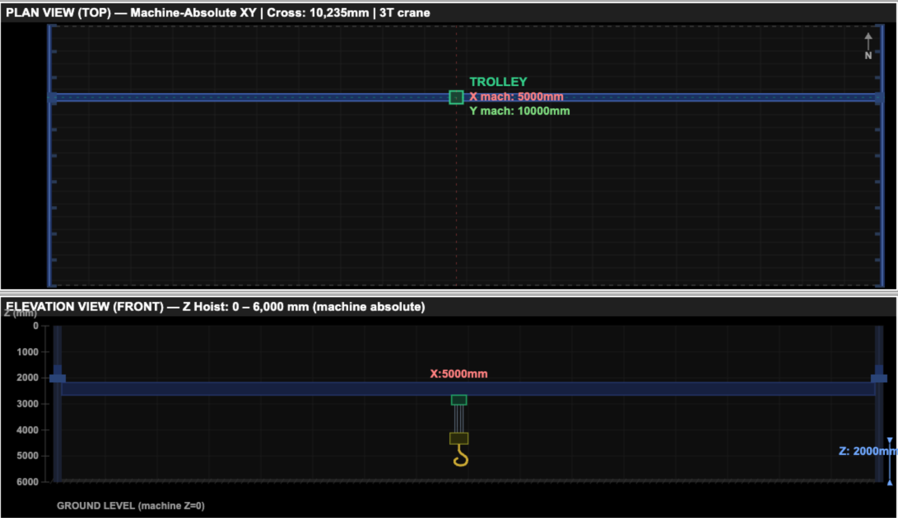
Fig. 5. Software prototype showing the position display
Map views: Schematic top-down and side-view representations of the crane’s travel envelope are proposed, with the configured scan region overlaid. A dedicated scan-progress view is proposed to distinguish visited grid points from remaining points, together with a live position indicator.
Manual controls: A press-and-hold jog control is created, intended to replicate the function of the existing radio remote. Home, local zero-reset, stop, and direct coordinate-entry controls are proposed, along with a facility-wide stop command and a software-based on-screen stop control. The on-screen stop control is intended only to issue a standard stop command through software, and is explicitly not proposed as a substitute for the crane’s hardwired safety systems or the physical emergency-stop control on the radio remote.
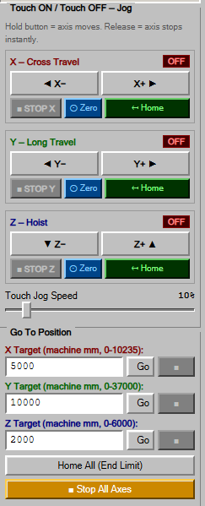 | 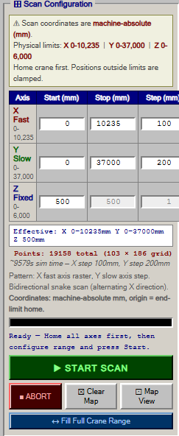
Fig. 6. Manual motion-control interface | Fig. 7. Scan Configuration

System Log: A diagnostic panel is proposed to display MODBUS request and response in a readable form, intended to allow observed mechanical behavior to be correlated with specific communication events during future testing, without requiring separate test equipment.
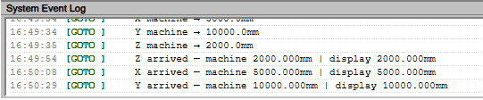
Fig. 8. Software event log displaying communication messages and crane status
Scan Configuration: A scan configuration panel is proposed, allowing the user to set travel limits and endpoints for the scan region. From these, the software generates a raster scan path, moving through the region one grid point at a time in sequence. This panel is included so that a scan region can be defined and validated once, rather than requiring each grid point to be entered and checked manually.
- Sources of Positioning Uncertainty
This section identifies mechanical and control-related factors expected to contribute to positioning uncertainty on disc-brake, variable frequency drive (VFD). driven crane systems, based on the general operating characteristics of this class of hardware. None of these factors have yet been characterized on the crane considered in this paper; their individual and combined contributions are identified here as subjects for future experimental investigation.
The crane considered here is a single-girder EOT crane. Motion along each axis is produced by a geared motor driving the trolley wheels along the rail, and a disc brake mounted on the motor shaft is used to hold position when the drive is not commanded to move. Each motor is driven by a VFD, which controls speed by varying the supply frequency and does not use position feedback. So the full mechanical chain goes from the motor, through the gearbox, through the brake, to the wheels on the rail, and finally to the actual trolley position. Every link in that chain can add some uncertainty, which is what the rest of this section goes through one by one.
Brake-engagement behavior: The crane’s mechanical brake is spring-applied and electromagnetically released. The timing characteristics of engagement and release are expected to depend on factors such as pad condition, coil temperature, and applied load, and are expected to introduce variability into stopping behavior that a closed-loop controller relying on continuous correction may interact with unfavorably, since the brake operates largely independently of the drive’s speed command.
Drivetrain compliance and gearbox backlash: Compliance just means the shafts, couplings, and structural members aren't perfectly rigid — they flex a little under load before the motion actually reaches the crane structure. Backlash is the small gap between gear teeth in the gearbox; when the motor starts moving or reverses direction, it has to rotate through this gap before it actually starts driving the load. Both effects mean the motor can turn a certain amount without the crane structure moving by exactly the same amount. Therefore there is an unquantified displacement between commanded motor motion and actual structural motion.
Wheel-rail interaction: Contact behaviour between the trolley wheels and the rail, including clearance and surface condition, is expected to introduce additional positioning un-certainty that is difficult to predict analytically and is more readily characterized through direct measurement.
Encoder mounting location: Because the encoder is proposed to be mounted on the moving trolley structure rather than on the payload itself, it is expected to measure structural position rather than the position of a suspended probe or antenna, introducing an additional, currently unquantified source of uncertainty for suspended-load configurations.
The combined effect of these factors on achievable positioning accuracy has not yet been measured and will be evaluated during future experimental validation, as outlined in Section IX. No numerical accuracy or jitter values are reported in this paper, as none have been experimentally obtained.
- Proposed Control Strategy
Motivated by the sources of positioning uncertainty discussed in Section VII, this paper proposes a control strategy intended to reduce the likelihood of repeated corrective reversals during positioning, rather than relying on continuous closed-loop correction. The following principles form the basis of this preliminary strategy; they describe intended behavior and have not yet been implemented or experimentally validated.
Single command per state transition: A new speed command would be issued only upon a change in control state, rather than being retransmitted continuously, with the aim of maintaining an unambiguous drive command state.
Avoidance of corrective reversal: Rather than reversing direction to correct an overshoot, the strategy is to accept the resulting position and proceed to the next commanded target, based on the expectation, informed by the brake behavior discussed in Section VII, that corrective reversal is more likely to introduce oscillation than to resolve it.
Tolerance-based completion: A stop occurring within a configurable tolerance of the commanded target would be treated as a completed move, rather than triggering further corrective action. Settling interval prior to position logging: A fixed wait interval following a stop command is proposed prior to logging the final position, with the aim of avoiding misattribution of continued mechanical settling as positioning error.
Whether the drive should additionally be commanded to stop in advance of the target position, to compensate for coast-down following the stop command, remains an open design question. This has not been resolved, as it depends on quantities that can only be determined through direct measurement once hardware is available, and is therefore not included in the control strategy proposed in this paper.
A. Proposed State Machine
The control logic is organized around six states: IDLE, HOME, FAST, CREEP, STOP, and DONE, with speed in-tended to step down monotonically within a single move. HOME is intended to drive an axis toward its limit switch and establish the machine-absolute origin. FAST, and CREEP are intended to represent successively reduced commanded speeds as the target is approached. STOP is intended to trigger once the target is reached within the configured tolerance, followed by the settling interval described above, after which the final position would be recorded and the state machine would transition to DONE, and subsequently to IDLE pending the next command. This state machine describes proposed control logic and has not yet been implemented or tested.
- Planned Validation Methodology
No experimental validation has been performed at the time of writing. This section outlines the validation methodology planned for future work, once hardware has been procured and installed.
Bench testing (pre-installation): planned activities include verifying the encoder resolution given in Eq. 1 against a known physical displacement; characterizing wireless link range and reliability under representative facility conditions; verifying MODBUS communication with the motor isolated, cross-checked against the drive manufacturer’s documentation; and verifying the complete command-and-motion chain at reduced speed, with resulting motion compared against the encoder log.
Positioning characterization: Repeated positioning trials are planned to experimentally quantify positioning accuracy [9], repeatability, and to determine the individual contributions of the factors identified in Section VII.

A. Preliminary Bill of Materials
A preliminary cost estimate for components is below 10,000 Rs, covering controller boards, RS-485 transceiver modules, power supplies, antennas, shielded cabling, protection components, the enclosure, cable glands, terminal blocks, and a custom encoder-mounting bracket, required because the existing motor provides no built-in provision for shaft-encoder mounting. (This estimate is expected to be revised currently its denoted for only one axis movement)
- Discussion and Limitations
Separation of the control path from the wireless monitoring and interface paths ensures that degraded wireless connectivity or an unresponsive browser interface does not directly affect crane motion. This design choice allows the control loop to continue operating on its most recently received set point. This is presented as a design rationale rather than a demonstrated property, and experimental verification is planned once hardware is available.
Several limitations of the proposed design are identified below, along with how each is intended to be addressed.
- The encoder is proposed to be mounted on the crane structure rather than on the suspended payload, which is expected to introduce an error between measured and actual probe position. This offset will be measured directly once hardware is installed and can then be corrected for in software, or, if the offset proves inconsistent, addressed by adding a second position reference closer to the payload.
- The hoist axis is held at a fixed height during scanning, so the current system supports 2D scanning only. Z-axis control is planned as a future addition once X-axis motion has been validated.
- The on-screen stop control only issues the standard software stop command and does not connect to the crane's safety circuitry beyond the home limit switch. The existing hardware emergency stop and radio remote remain the sole certified safety devices; the on-screen stop is not intended to replace them.
- Since there is no way to mount an encoder directly on the motor to measure true displacement, the system will instead be validated by commanding the crane to known set points at different positions along the axis and comparing the commanded position against the encoder reading at each point.
The present work is limited to conceptual design and software implementation, it establishes the system architecture and automation framework necessary before hardware integration. Early development of the software and control logic enables systematic evaluation of coordinate management, motion sequencing, and safety functions, thereby reducing implementation risk during subsequent hardware deployment.
- Conclusion
This paper presents the conceptual design and software realization of an EOT-crane-based positioning platform intended for future large-aperture antenna characterization. The work establishes the overall system architecture, communication framework, motion-control strategy, uncertainty analysis, scan-planning methodology, and browser-based supervisory interface. Software simulations demonstrate the feasibility of the proposed control and coordinate-management concepts. Since hardware implementation has not yet been completed, no positioning or antenna measurement results are reported. Future work will focus on hardware integration, positioning characterization, and experimental validation using representative antenna measurement scenarios.

ACKNOWLEDGEMENT
The authors gratefully acknowledge Soumya Sarkar, Director, SAC-ISRO, and Sanjeev Kulshrestha, Dy. Director, Antenna Systems Area-SAC-ISRO, for their inspiration, motivation, and continuous support throughout this work. The authors also thank Dr. D. Ram Rajak, Group Director, SAC; Sasmita Chaurasia, Head, SRTD; and Shri Vivek Singh, Deputy Director, MISA, SAC, for their encouragement and support.

REFERENCES
- J. E. Hansen, Spherical Near-Field Antenna Measurements. London, U.K.: Peter Peregrinus Ltd., 1988.
- A. C. Newell, "Error analysis techniques for planar near-field measurements," IEEE Transactions on Antennas and Propagation, vol. 36, no. 6, pp. 754–768, Jun. 1988.
- A. D. Yaghjian, "An overview of near-field antenna measurements," IEEE Transactions on Antennas and Propagation, vol. 34, no. 1, pp. 30–45, Jan. 1986.
- IEEE Standard for Near-Field Antenna Measurements, IEEE Std 1720-2012, IEEE, 2012.
- NSI-MI Technologies, Planar Near-Field Antenna Measurement Systems, NSI-MI Technologies, Suwanee, GA, USA. [Online]. Available: https://www.nsi-mi.com⁠
- TICRA, GRASP—Technical Description, TICRA, Copenhagen, Denmark. [Online]. Available: https://www.ticra.com⁠
- Modbus Organization, MODBUS Application Protocol Specification V1.1b3, Apr. 2012. [Online]. Available: https://modbus.org⁠
- Yaskawa Electric Corporation, S1000 Technical Manual (MEMOBUS Communication), Yaskawa Electric Corp., Kitakyushu, Japan.
- Renishaw plc, RESOLUTE™ Absolute Encoder System—Technical Documentation, Renishaw plc, Gloucestershire, U.K.
- ISO 230-2:2014, Test Code for Machine Tools—Part 2: Determination of Accuracy and Repeatability of Positioning of Numerically Controlled Axes, International Organization for Standardization, Geneva, Switzerland, 2014.

